A Study onThe BLACK MONEY (UNDISCLOSED FOREIGN INCOME AND ASSETS) AND IMPOSITION OF TAX ACT, 2015

CA Pradip K Modi

pkm@pkmodi.com

One day a boy is asking to his bench mate to play a guessing number game . A bench mate politely answers, why not to play Black money number game, in which any guess number will be neither correct nor incorrect answer. It is true that, no one knows the correct number for generation of black money. The National Institute of Public Finance and Policy (NIPFP), In its 1985 report on Aspects of Black Economy, the NIPFP defined ‘black income’ as ‘*the aggregates of incomes which are taxable but not reported to the tax authorities’.*IMF estimates global black money– excluding Switzerland, China, Taiwan and Oil exporting economies — at $18 trillion (RS .1152 lacs Crores)

It is true that illicit financial flow making its way from developed countries as well as developing countries for varieties of reasons. Financial Transparency Coalition,NGO, based out of Washington,DC,has published a report , Illicit Financial Flows from Developing Countries: 2003- 2012 includes following table for better appreciation for stashing Black money in Tax Havens.

Illicit Financial Outflows from the Top 10 Developing Economies, 2003-2012

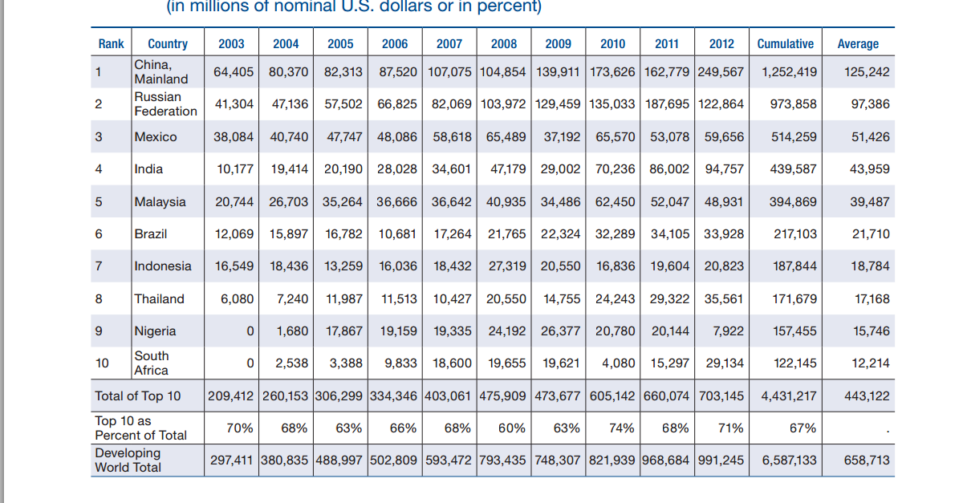

Thus it is guess from the report that almost 40% ( $ 440 Billion = @ INR 64 = Rs.28 Lacs crore ) of Annual GDP of our country is accumulated in form of Black Money.

It is not necessary that whole amount of black money is generated through illegal activities but sure that such money is untaxed. Significant amount of black money, however, is generated through legally permissible economic activities, which are not accounted for and disclosed or reported to the public authorities as per the law or regulations, thereby converting such income into black money. The failure to report or disclose such activities or income may be with the objective of evading taxes or avoiding the cost of compliance related to such reporting or disclosure.

Indian Black Money Abroad In Secret Banks and Tax Havens Second Report Of The Task Force on the steps to be taken by India was prepared and submitted on Dated 31st January 2011 by Mr.S. Gurumurthy, Mr.Ajit Doval, Mr. R. Vaidyanathan and Mr. Mahesh Jethmalani, clearly asked the then UPA II government, Why does India not follow the examples of such small countries like Philippines, Peru, Nigeria, and Tunisia, which have chased the corrupt wealth of their rulers? Why does it not use its increasing geo-political power to bring backthe black monies stashed abroad by Indian nations? etc.

There after Ministry Of Finance,Department of Revenue, CBDT, New Delhi came out with WHITE PAPER , May 2012 on BLACK MONEY. The paper suggests that how Black Money is being generated in the following diagram.



This may be one of the genesis for black money apart from illegal mining, smuggling, bribery, Corruption etc.

on the 19th of January-2011 , the Supreme Court of India made an historic observation about this shameful phenomenon of Indian funds kept illegally abroad in the following words;

“***Justice Reddy, after perusing the list, told the SG: “This is all the information you have or you have something more! We are talking about the huge money. It is a plunder of the nation. It is a pure and simple theft of the national money. We are talking about mind-boggling crime. We are not on niceties of various treaties.”***

All these actions and public opinion along with determination of NDA government passed the Bill in Parliament on 26thMay ,2015 and published after assent of President on 27th, May 2015 as a part of Constitutional, legal, geo-political, moral and ethical measures to recover the Indian wealth illegally stashed away abroad.

The Government has also notified Rules related to the valuation of assets held and owned outside India and certain other procedural aspects on 2.7.2015.

The Government has declared Compliance window to declare under section 59 of this act and come out clean in relation to assets owned or income sourced outside India, which never have been disclosed in the Income tax Return filed under section 139 of I T Act. The period of compliance window starts from 1.7.2015 and ends on 30.9.2015 for declaring assets. The tax at the rate 30% under section 60 and penalty at the rate of 30% under section 61 should be paid on or before 31.12.2015.The amount paid under this scheme is non refundable. No interest under section 234A , 234 B or 234C is payable. Short payment of tax or penalty will bring these assets under computation of Income under this act and will be subject to all other provisions of this act. This failure will attract 30% tax and under section 41 of this act 90% penalty plus prosecution etc.

**Application of Act:**

This act will be applicable from A Y 2016-17

**To whom this Act applies:**

A person includes every person who is deemed to be an assessee in default under this Act, being a **Resident and Ordinary Resident**by whom tax or any other sum of money remains unpaid, which is payable under this Act,after 31.12.2015, in respect of undisclosed foreign income and assets or incorrectly disclosed Foreign Income and assets before 30.9.2015.

In other words those, who choose to take benefit of limited period of compliance window to come out clean by declaring undisclosed foreign assets created from foreign source of income or unable to satisfy the source from where such assets held,will not be hit by majority provisions of this act .

**Nature of Income and Assets to attract provisions:**

The Assets located outside India and source of Income also outside India, are covered under the provisions of this act. The assets located outside India must be owned by a PROR(Person Resident and Ordinarily Resident) or he must be holding beneficial interest there in and source of investment is unable to disclose or explanation provided by PROR in the opinion of Income Tax officer is unsatisfactory.

**Whether foreign income and foreign assets both are covered for tax payment?**

No, only foreign assets are valued as per valuation Rule prescribed under The BLACK MONEY (UNDISCLOSED FOREIGN INCOME AND ASSETS) AND IMPOSITION OF TAX RURLE, 2015 .

**How the valuation of assets located outside is to be done ?**

1. value of bullion, jewellery or precious stone shall be the higher of,- (I) its cost of acquisition; and (II) the price that the bullion, jewellery or precious stone shall ordinarily fetch if sold in the open market on the valuation date for which the assessee may obtain a report from a valuer recognised by the Government of a country or specified territory outside India or any of its agencies for the purpose of valuation of bullion, jewellery or precious stone under any regulation or law;
2. valuation of archaeological collections, drawings, paintings, sculptures shall be higher of cost or valuation certificate on declaration date ;
3. valuation of shares and securities,—

Listed: cost or market average value of high and low price of valuation date;

Unquoted : cost or sum of value comprise of book value for other than bullion , jewellery, precious stone, shares and securities and immovable properties along with market value as per valuation certificate for bullion, jewellery, precious stone, shares and securities and immovable properties ;

1. the fair market value of an immovable property shall be higher of, (i) its cost of acquisition; and (II) the price that the property shall ordinarily fetch if sold in the open market on the valuation date for which the assessee may obtain a valuation report from a valuer recognised by the Government of a country or specified territory outside India in which the property is located or any of its agencies for the purpose of valuation of immovable property under any regulation or law;
2. value of an account with a bank shall be,-

(I) the sum of all the deposits made in the account with the bank since the date of opening of the account; or (II) where a declaration of such account has been made under Chapter VI and the value of the account as computed under sub-clause (I) has been charged to tax and penalty under that Chapter, the sum of all the deposits made in the account with the bank since the date of such declaration:

Provided that where any deposit is made from the proceeds of any withdrawal from the account, such deposit shall not be taken into consideration while computing the value of the account.

**Whether undisclosed Assets located outside can be gifted or otherwise?**

Where such asset was transferred without consideration or inadequate consideration before the valuation date, the fair market value of the asset shall be higher of its cost of acquisition and the fair market value on the date of transfer.

**How to convert Currency value in Rupee Value for Taxation?**

The fair market value of an asset determined in a currency which is one of the permitted currencies designated by the Reserve Bank of India under the Foreign Exchange Management Regulations, shall be converted into Indian currency as per the reference rate of the Reserve Bank of India on the date of valuation.

**Whether Partly Disclosed Assets and Income also covered ?**

The assets located outside India and income sourced outside India will be spared to the extent of disclosure of foreign assets and Income declared under regular Income Tax return filed or declared under section 59 of this act.

**Whether any deduction of Expenses allowed while computing Income under this act?**

No expenditure can be claimed.

**Whether Income and assets computed will be part of Income under Income Tax Act**?

Undisclosed foreign sourced Income and assets computed under this law will not form part of Computation of Income under Income Tax Act.

**Whether third party can be involved in the assessment proceedings?**

Yes, under section 14 of this act , the person who is holding assets outside India or interest on behalf of PROR can be called on without any fetter of provisions of this act. The manager which includes Managing director of company and in case of unincorporated entity all partners jointly and severally liable to pay tax demand.

**Whether third party or Debtors ( any sum receivable by assessee) liable to tax demand?**

Yes, Tax Recovery office may ask concerned party to pay a tax demand. Under section 32(14) , TRO can initiate proceeding under section 32 of this act and manner as laid down under second schedule of Income Tax Act.

**What is penalty for non co operating or furnishing information by third party?**

Under section 45 a sum of Rs.50,000 ,which may be increased to Rs 2,00,000.

**What is penalty Where assesse failed to furnish or furnished inaccurate information?**

Non filing of information in relation to assets held outside India or source of income outside India in return filed under section 139, attracts penalty of Rs 10 lacs under section 45 of this act. However all Bank balance in aggregate does not exceed Rs 5 Lacs, no penalty under section 42 is payable.

**Penalty for filing of misinformation or to abet or inducing to file false evidences?**

The proceeding under section 9 of this act is construed as proceeding under section 193 of Indian Penal Code. Under section 53 any professionals, bank, institutions who encourage to file incorrect or untrue evidences will be subject to prosecution and imprisonment for 6 months to 7 years.

**Whether declaration made under this act will affect wealth tax return filed?**

No, to the extent declared under section 59 of this act. In case no declaration filed or in other words benefit of compliance window not availed, the provisions of wealth tax are also applicable.

**Which are valid evidences for computing Tax under this act?**

Under section 57 of this act, the evidences which are in possession of Tax Authority will be valid documents for computing tax under this act.

**Who can not avail benefit of section 59 for filing declaration?**

1. Any person , in respect of whom an order of detention has been made underthe Conservation of Foreign Exchange and Prevention of Smuggling Activities Act,1974, in relation to prosecution for any offence punishable under Chapter IX or Chapter XVII of the Indian Penal Code, the Narcotic Drugs and Psychotropic SubstancesAct, 1985, the Unlawful Activities (Prevention) Act, 1967, the Prevention of CorruptionAct, 1988;
2. Any person notified under section 3 of the Special Court (Trial of Offences

Relating to Transactions in Securities) Act, 1992.

1. in relation to any undisclosed asset located outside India which has been acquired from income chargeable to tax under the Income-tax Act for any previous year relevant to an assessment year prior to the assessment year beginning on the 1st dayof April, 2016—

(*i*) where a notice under section 142 or sub-section (*2*) of section 143 or section 148 or section 153A or section 153C of the Income-tax Act has been issued in respect of such assessment year and the proceeding is pending before the Assessing Officer; or

(*ii*) Where a search has been conducted under section 132 or requisition has been made under section 132A or a survey has been carried out under section 133A of the Income-tax Act in a previous year and a notice under subsection *2*) of section 143 for the assessment year relevant to such previous year or a notice under section 153A or under section 153C of the said Act for an assessment year relevant to any previous year prior to such previous year has not been issued and the time for issuance of such notice has not expired; or

(*iii*) where any information has been received by the competent authority under an agreement entered into by the Central Government under section 90 or section 90A of the Income-tax Act in respect of such undisclosed asset.

**Whether proceedings under this act will limit the action under any other act**?

No. Even The Prevention of Money-laundering Act, 2002, will include the offence committed under this act as cognizable offence.

Truly speaking, one does not know immediate outcome of this Act but one thing is certain that this act will act as a deterrent for Black money generation in coming days.